

# School of InfoComm Technology

**Deep Learning Assignment**

Diploma in CSF / FI / IT

April 2022 Semester

**ASSIGNMENT 1**

(30% of DL Module)

16th May 2022 – 10th June 2022

**Submission Deadline:**

**Presentation: 10th June 2022 (Sunday), 11:59PM**

**Report and Code: 10th June 2022 (Sunday), 11:59PM**

|  |  |  |
| --- | --- | --- |
| **Tutorial Group** | **:** | **T01** |
| **Student Name** | **:** | Dominic Lee |
| **Student Number** | **:** | S10222894 |

**Penalty for late submission:**

10% of the marks will be deducted every calendar day after the deadline.

**NO** submission will be accepted after 19th June 2022 (Sunday), 11:59PM.

Table of Contents

1

[School of InfoComm Technology 1](https://connectnpedu-my.sharepoint.com/personal/s10222894_connect_np_edu_sg/Documents/Polytechnic/Year%202%20Semester%201/DL/Asg%201/Assignment%201%20Report_Dominic.docx#_Toc106399971)

1 Overview 3

2 Data Pre-processing and Data Loading 4

3 Develop the Image Classification Model 5

Analysis 33

4 Evaluate Models Using Test Images 39

5 Use the Best Model to Perform Classification 40

6 Summary 43

# Overview

Describe the problem, the objective, and the approach.

Objective:

The objective of this assignment is to build a convolutional neural network model that can appropriately classify 10 different kinds of food given an image of the food. The aim is to have a model that can best classify the food into their correct categories with the highest accuracy.

Problem:

The problem we face is that an image of the same food can vary a lot, from the rotation of the food to where the food is positioned in the picture, and we need to ensure that our model has spatial invariance so that no matter how the image is contorted, our model should still be able to classify it. Furthermore, there isn’t a lot of data to be used to train the model and data is extremely important in improving a model’s performance. Lastly it takes a long time to train the model, it will be difficult to try all the countless combinations of hyperparameters to accurately determine the best model as that would be too time consuming.

Approach:

**Model from scratch**

I intend to tune my model by tuning one hyperparameter at a time. There will be 9 hyper parameters that I will train they are:

1. Batch Size
2. No. of layers in convolutional layer & No. of neurons in convolutional layer
3. No. of dense layers & No. of neurons in dense layers
4. Optimizers
5. Learning rate
6. Weight Initialization
7. Batch normalization
8. Dropout
9. Regularizers

I will first start with a base model, from this base model, I will start to find the “optimal” hyperparameter for each hyperparameter by testing with different values. I will slowly build my model in this fashion. Though this is partially flawed as sometimes hyperparameters might counteract and potentially worsen the model when mixed in with another hyperparameter, this is the most systematic way of handling this problem.

**Pre-Train**

I will be using VGG16 to build my pre-train model. My approach for doing this is to build a model with no fine tuning, fine tune the model and then lastly prevent overfitting and see if the accuracy improves. As for my classifier, I will use an architecture which is not too complex but can capture the complexity of the data well. I will do this by experimenting with different number of layers and neurons in the layers.

# Data Pre-processing and Data Loading

Describe how you preprocess the data and load data into Jupyter Notebook

After uploading the data into their respective folder of ‘train’, ‘test’, and ‘validation’, I loaded the data in into the Jupyter Notebook using the code in the photo below

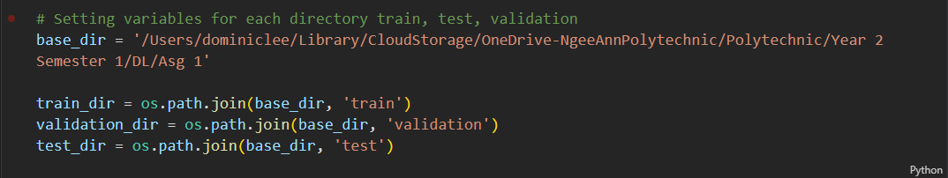

After loading the dataset, I performed data augmentation on my training data. I decided to use data augmentation as data is one of if not the most important things needed to develop a good model. And data augmentation increases the amount of data to train our model on by slightly modifying our original images in various ways.

I also rescaled my test and training data to put all my RGB values in a range from 0 to 1 instead of 1 to 255. This allows the model to have an easier time to learn and understand the data which translates to faster convergence.

Lastly, I then modified the dimensions of the image to be 100 by 100 pixels before creating two variables train_generator and validation_generator which will be used as my train and validation dataset during the training.

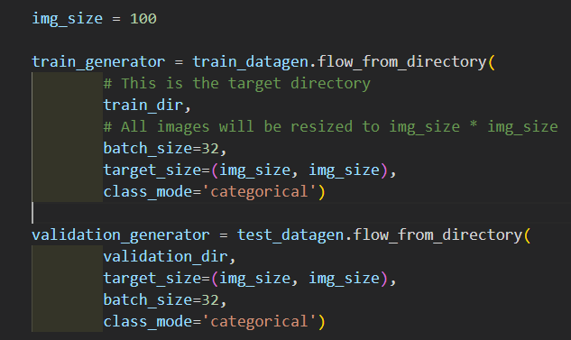

# Develop the Image Classification Model

**Model From Scratch**

**Base Model**

This will be the model that we start out with a very simple CNN model.

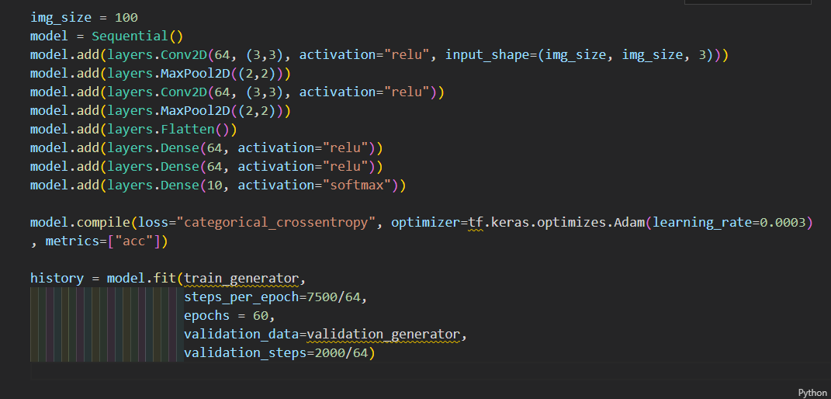

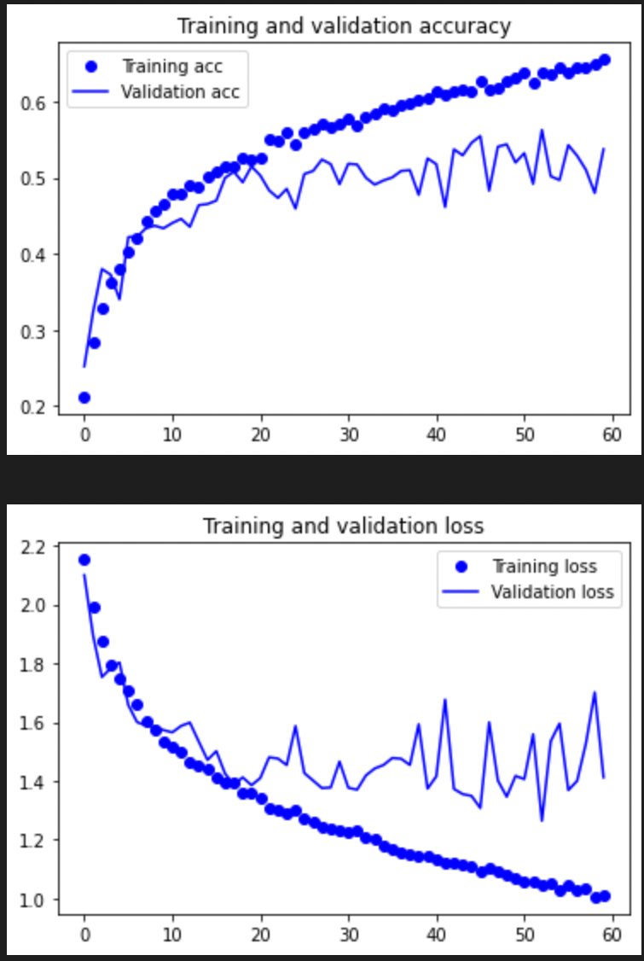

**Base Model**

Val accuracy before overfitting ~ 52%

Overfits ~ Epoch 45

1. Batch Size

Batch size is the number of training data the model trains with before taking a step towards the local/global minimum.

The first hyper parameter that I tuned is the batch size, this is because I believe that the batch size greatly affects how your model learns and the effect of batch size usually will not be affected by other hyperparameters.

Theory shows that batch sizes that are large have lesser noise and have a better gradient estimate, however in practice as the CNN is most likely non-convex (have local minimums), the more accurate gradient estimate might not lead us to the global minimum but a local minimum.

On the other hand, batch sizes that are small have more noise and can potentially let us escape local minimums during convergence, however if it is too small then the model will never converge as it would be too noisy. Smaller batch size also tends to converge faster than bigger.

Thus, we are looking for a batch size that is in the middle where it takes accurate steps toward the minimum, but small enough to escape any local minimums

I will be experimenting with batch sizes of 32, 64, 128, 256

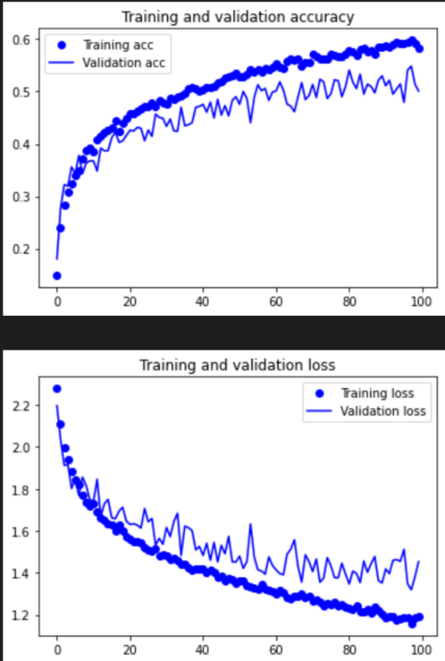

**Base – Batch Size 256**

Val accuracy before overfitting ~ 52%

Overfits ~ Epoch >100

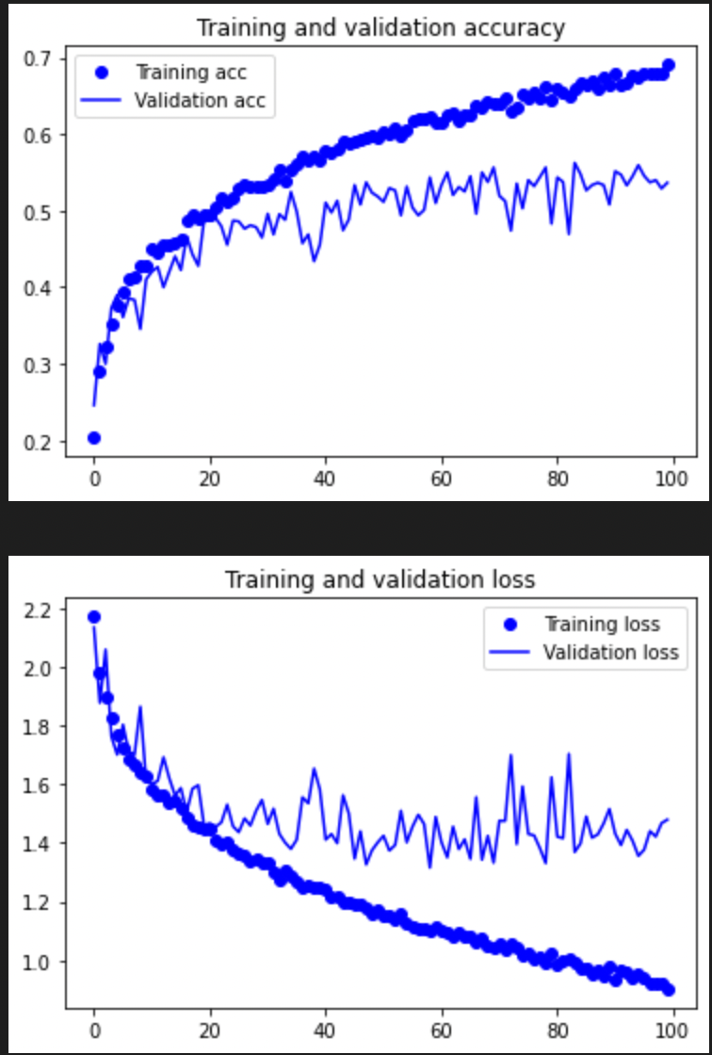

**Base – Batch Size 128**

Val accuracy before overfitting ~ 53%

Overfits ~ > Epoch 100

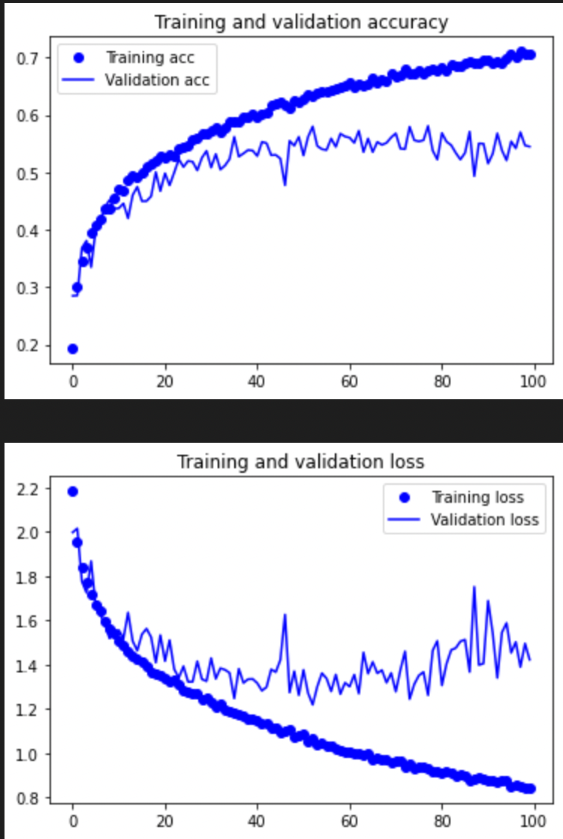

**Base – Batch Size 32**

Val accuracy before overfitting ~ 55%

Overfits ~ Epoch 70

**Analysis**

Comparing the 4 models, the model with batch size 32 gives us the highest validation accuracy and we will be using a batch size of 32 for the future models. It also converges the fastest of the four.

**Current Model Selected**



1. Number of convolution layers & neurons in each layer

For this assignment whenever there is a convolution layer, the next layer that follows will always be a Maxpooling layer. Hence if I mention the model have 2 convolutional layers, it means [Conv, Maxpool, Conv, Maxpool].

Here the next hyperparameter that I intend to tune is the model’s architecture starting with the number of convolutional layers and number of neurons in each of these layers.

The more filters a model has, the higher the complexity of features it can detect and the more feature it detects. With a model that is too complex overfitting will occur while with too simple a model, the model will not be able to learn and understand and the complexity of the data.

Similarly, the more neurons in each layer, the more parameter there are to tune allowing the model to capture data with a higher complexity. Too much will also lead to overfitting and too little will also likewise result in low accuracy.

For this/these hyperparameter/s, I added layers till it was complex enough. I did this by looking at how much the accuracy of the model improved. I also fixed my number of neurons trying 32, 64, 128 and 256. I trained both hyperparameters together as it is difficult to train them independent of each other.

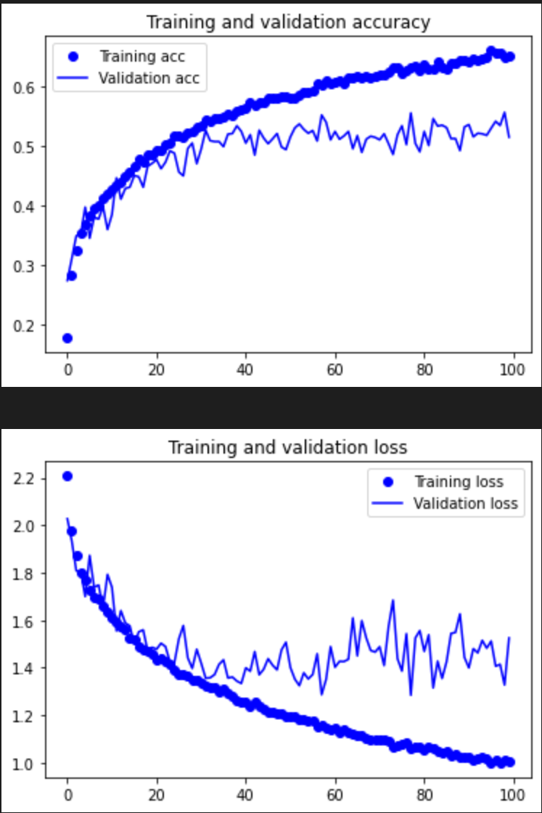

**Conv – 2L 32N**

Val accuracy before overfitting ~ 51%

Overfits ~

I believe that the model might be a little too simple and is taking a long time to converge. Or it might be taking a few more epochs to overfit.

No clear sign of overfitting using the graph.

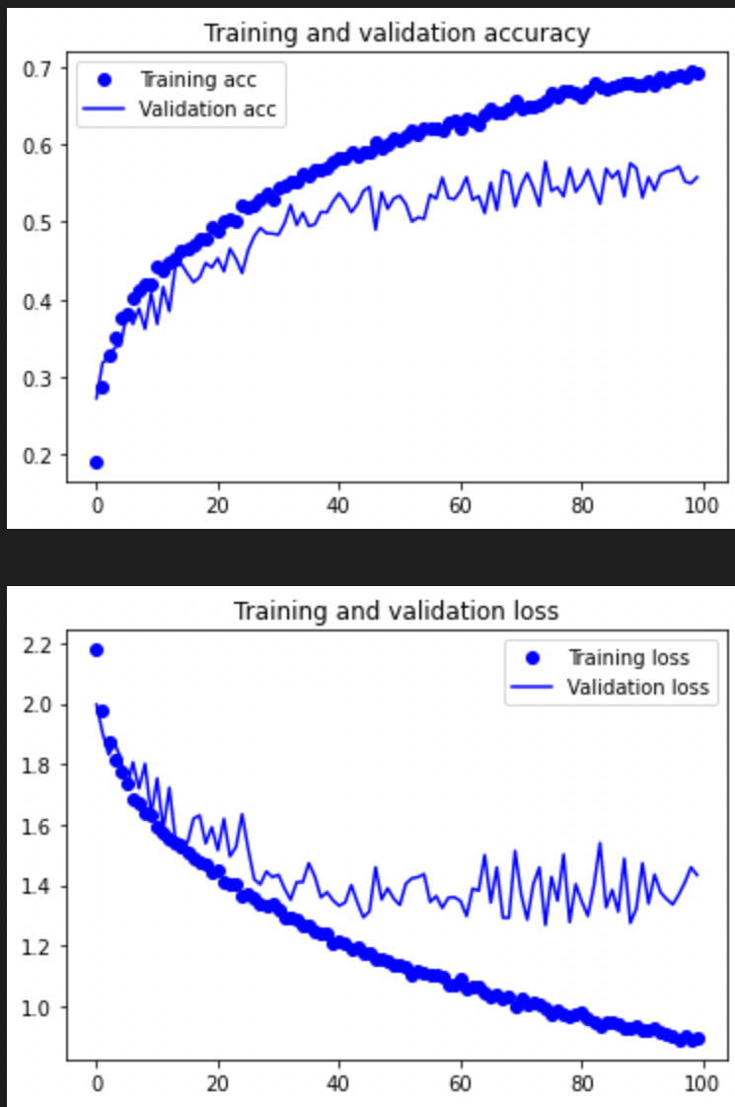

**Conv – 3L 32N**

Val accuracy before overfitting ~ 53%

Overfits ~ Epoch 90

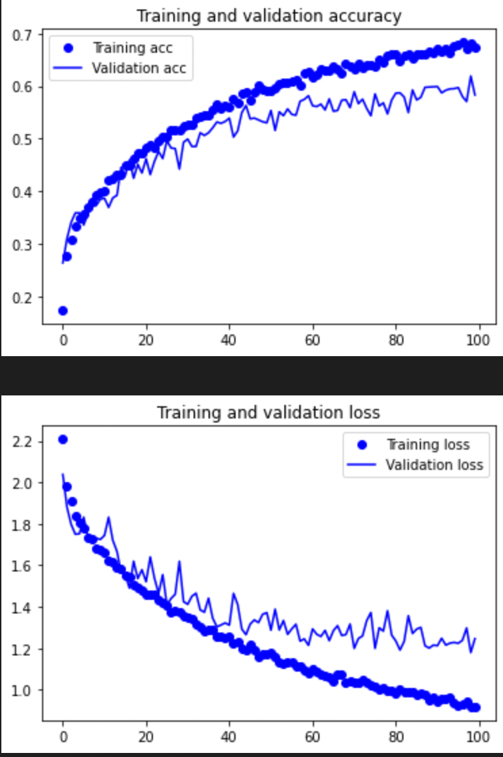

**Conv – 4L 32N**

Val accuracy before overfitting ~ 57%

Overfits ~ Epoch > 100

Although it has not overfitted yet, I assume that the accuracy will not increase.

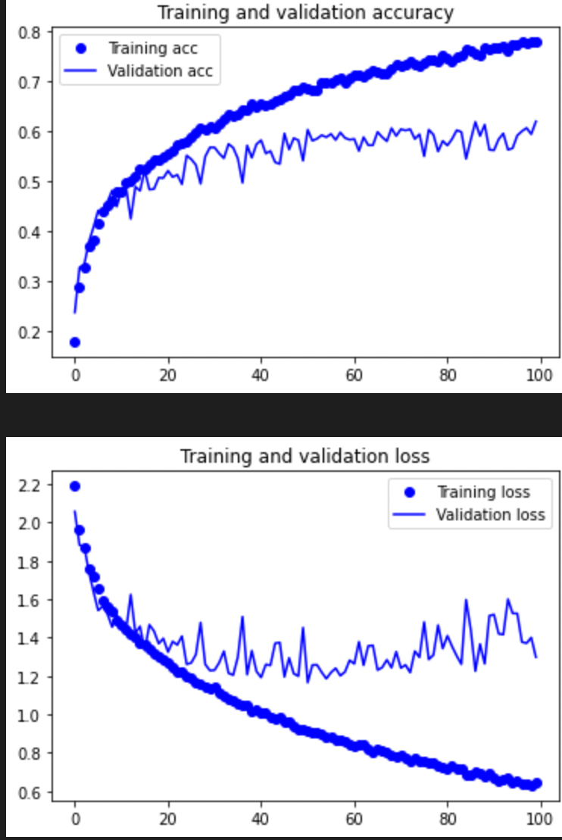

**Conv – 3L 64N**

Val accuracy before overfitting ~ 58%

Overfits at ~ Epoch 60

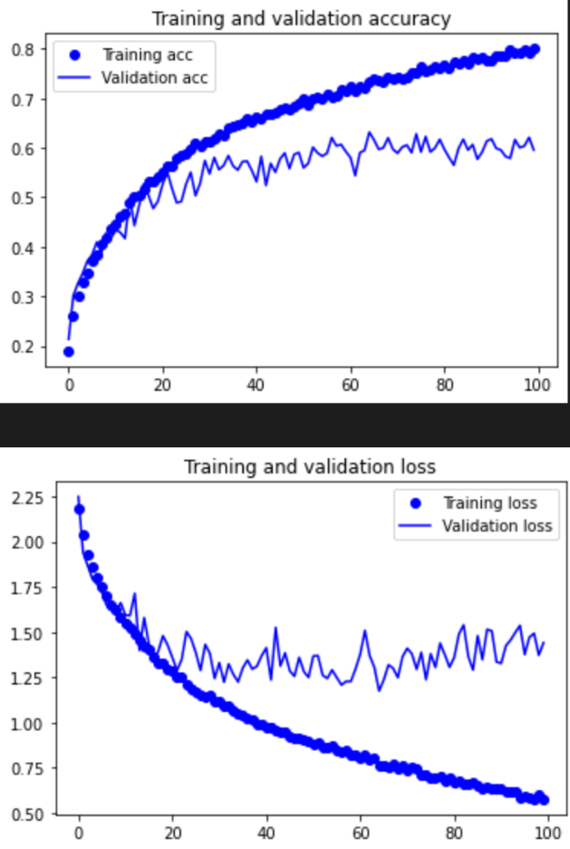

**Conv – 4L 64N**

Val accuracy before overfitting ~ 58%

Overfits at ~ Epoch 60

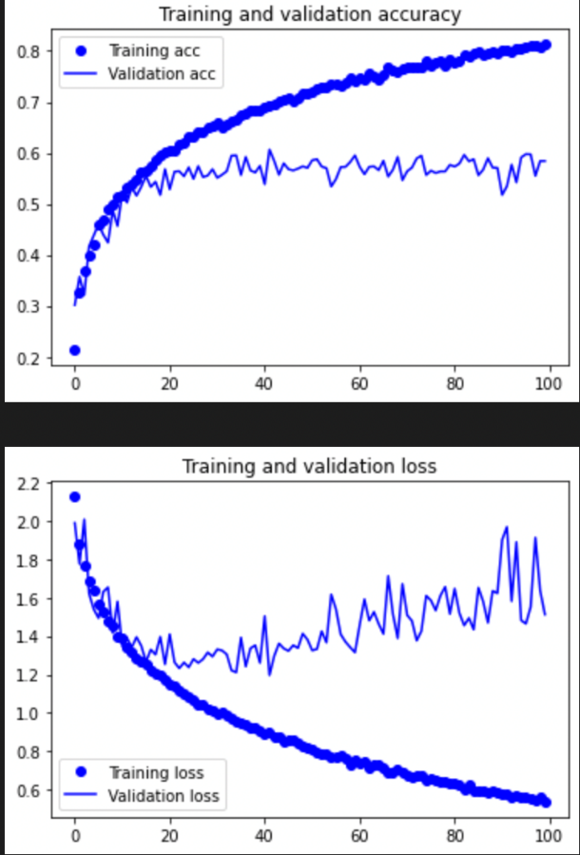

**Conv – 2L 128N**

Val accuracy before overfitting ~ 55%

Overfits at ~ Epoch 30

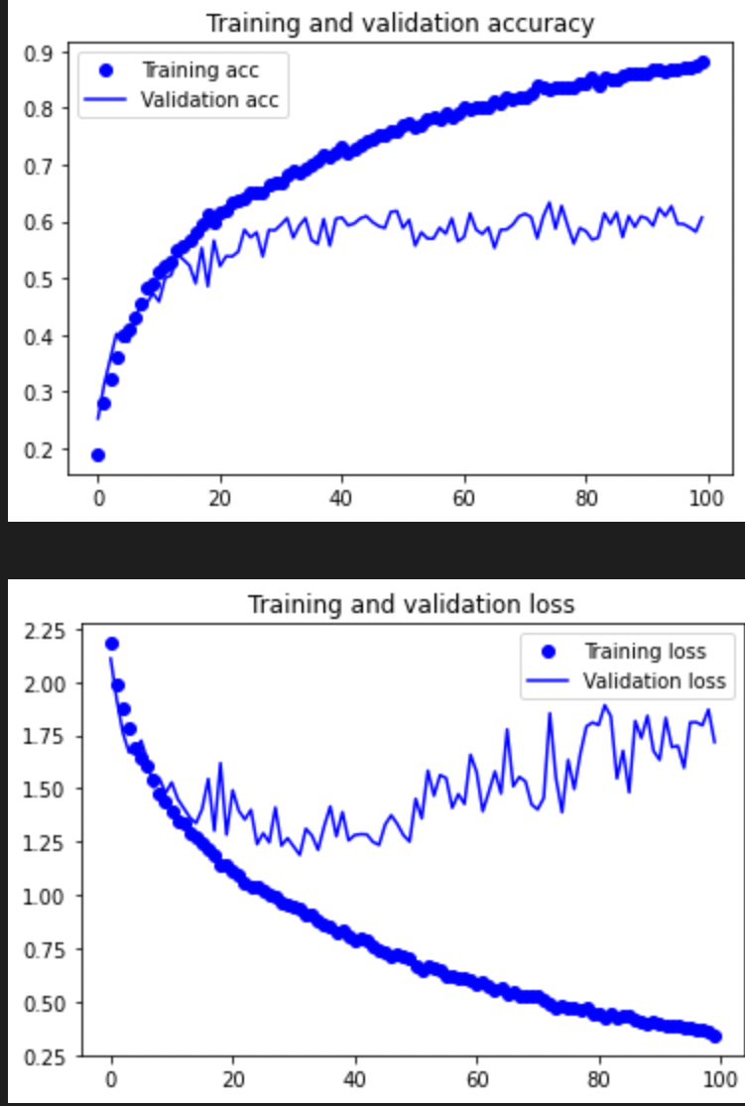

**Conv – 3L 128N**

Val accuracy before overfitting ~ 58%

Overfits at ~ Epoch 40

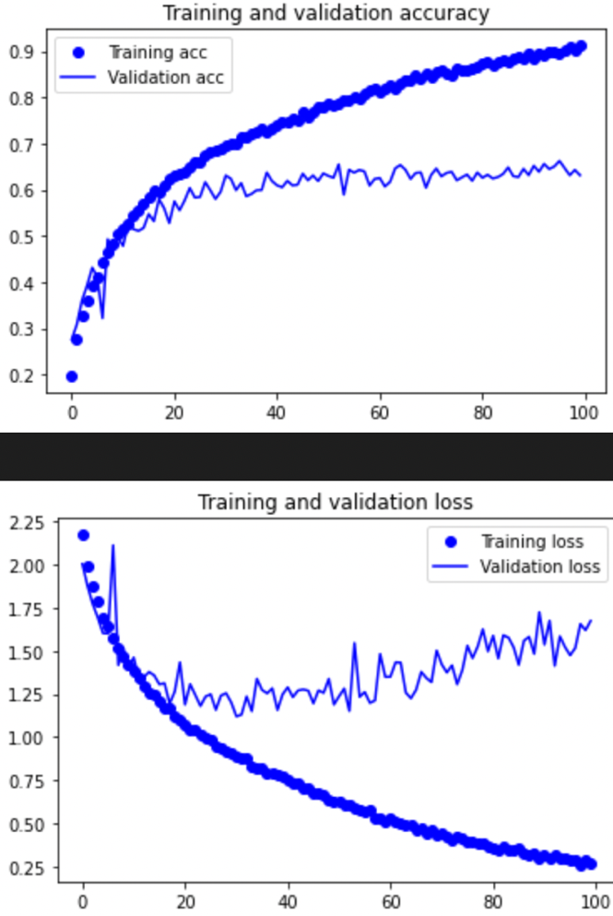

**Conv – 4L 128N**

Val accuracy before overfitting ~ 62%

Overfits at ~ Epoch 50

**Analysis**

Overall, the models I selected were the 4L 128N and 4L 64N. I picked 2 models here as I believe a model’s architecture play a key role in how accurate can become hence although the model with 64N is slightly less accurate I want to try further hyperparameters to see what happens.

Here we can see that models with 2 layers are too simple and it needs around 3 or 4 layers to really get better accuracy. But between 3 and 4 layers, the accuracy only has a slight increase. Indicating to me that 3 to 4 layers is complex enough.

I will call the 4L 128N model Conv 128 and the 4L 64N model Conv 64 for future references.

**Current Models Selected**

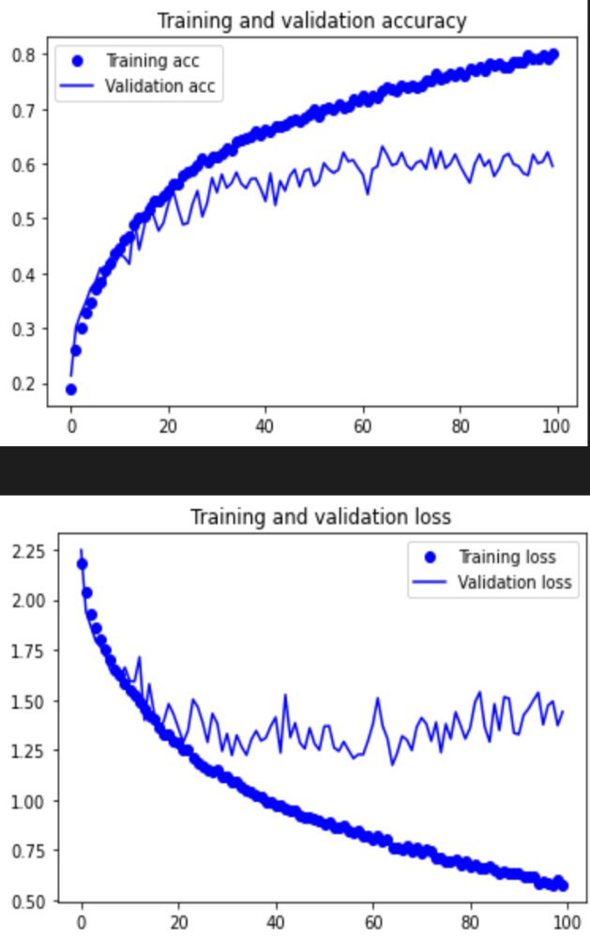

Figure 1 Conv 128 Figure 2 Conv 64

1. Number of Dense layers & Number of neurons in Dense layers

Here the hyperparameter that I am tuning is the classifier portion of the CNN. This is also part of the model’s architecture and after tuning these 2 hyperparameters, the model’s architecture will be complete.

Like the convolution layers, with too few dense layers, the model be too simple and will have low accuracies while with too complex a model, the model will overfit fast. The aim is also the same, where I get a model that is complex enough and doesn’t overfit too early.

Note that when I mention 2 dense layers it is excluding the output layer as that will remain constant. E.g., 2 dense layers [Hidden, Hidden, Output].

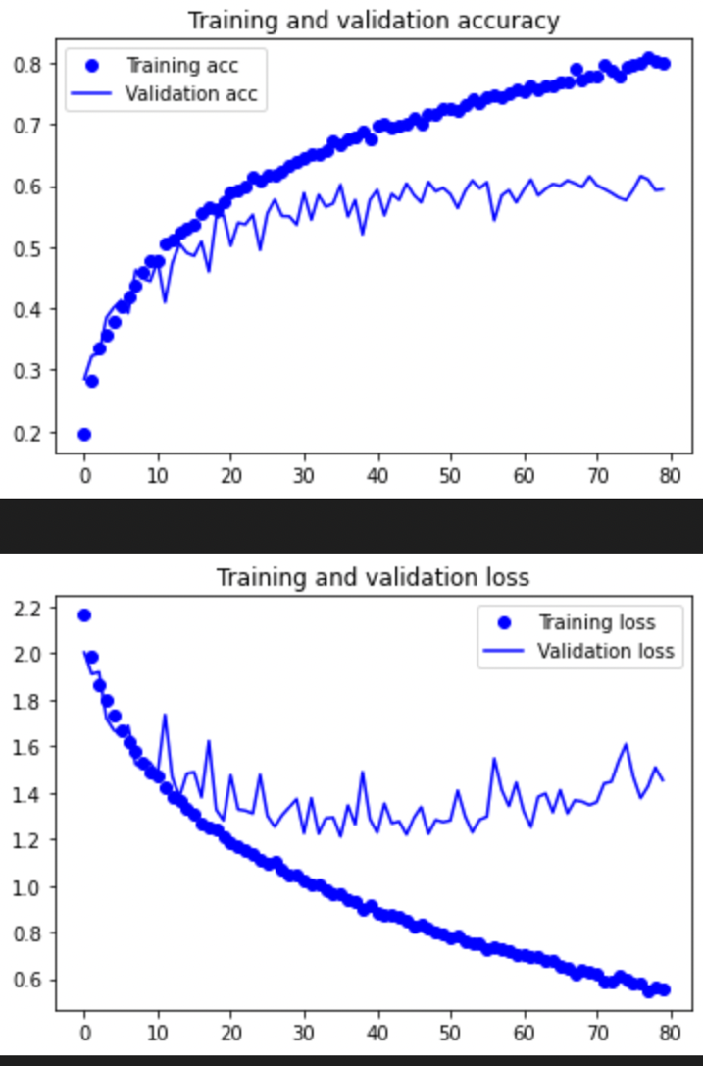

**Conv 64 DEN – 2L 128N**

Val accuracy before overfitting ~ 56%

Overfits ~ Epoch 60

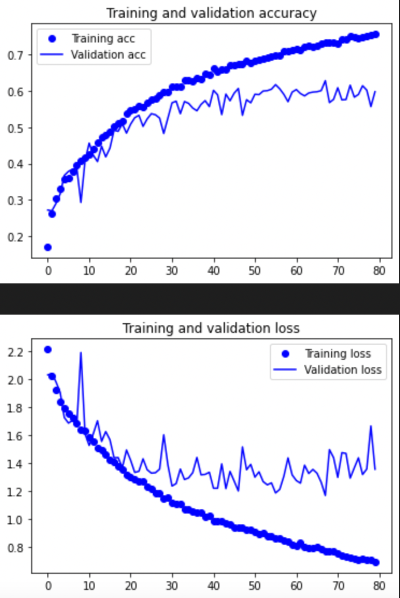

**Conv 64 DEN – 3L 64N**

Val accuracy before overfitting ~ 57%

Overfits ~ Epoch 60

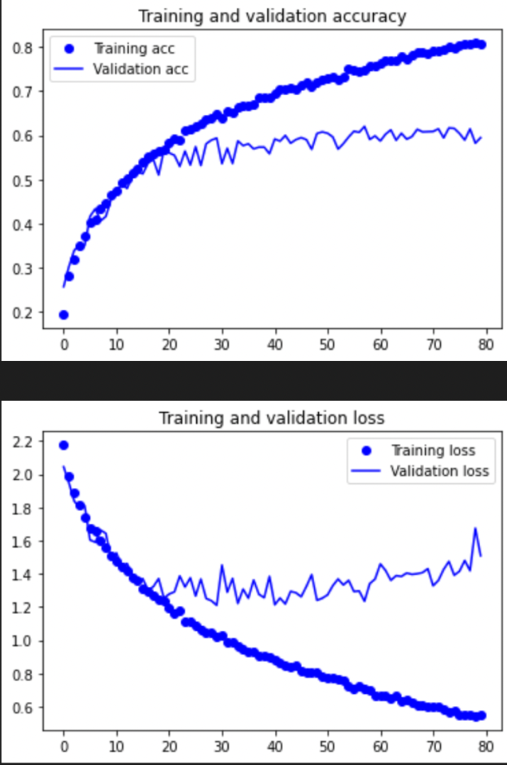

**Conv 64 DEN – 3L 128N**

Val accuracy before overfitting ~ 59%

Overfits ~ Epoch 50

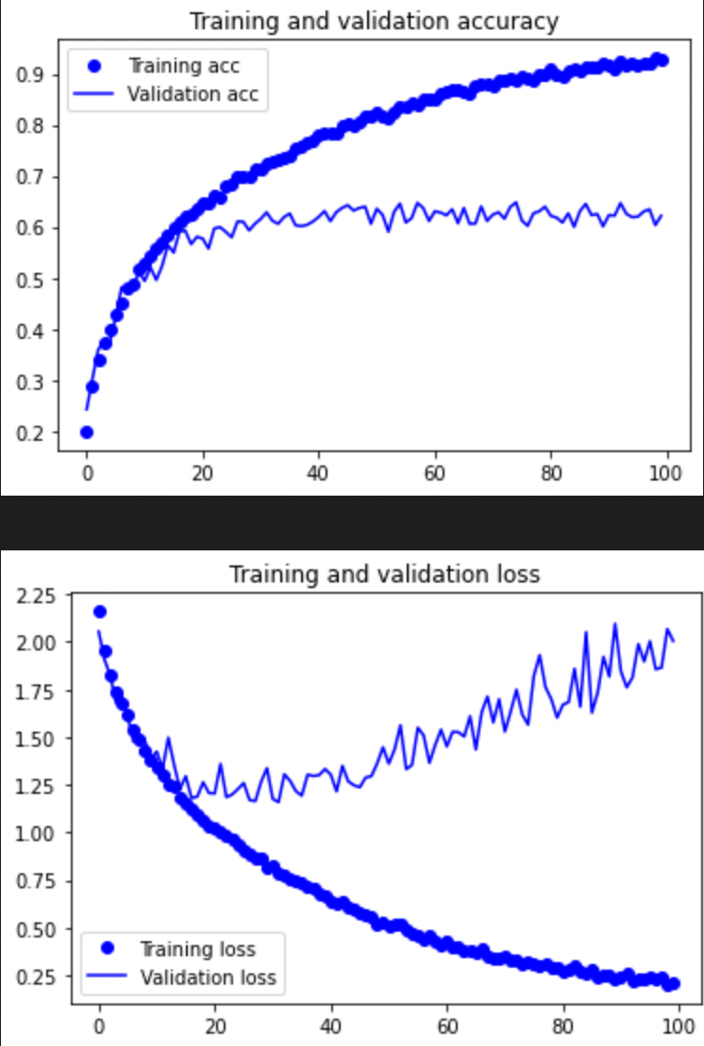

**Conv 128 DEN – 2L 128N**

Val accuracy before overfitting ~ 60%

Overfits ~ Epoch 40

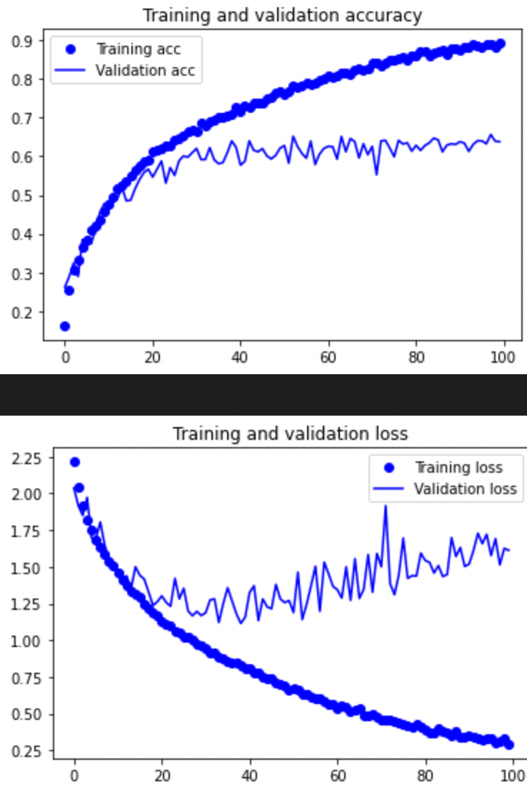

**Conv 128 DEN – 3L 64N**

Val accuracy before overfitting ~ 62%

Overfits ~ Epoch 40

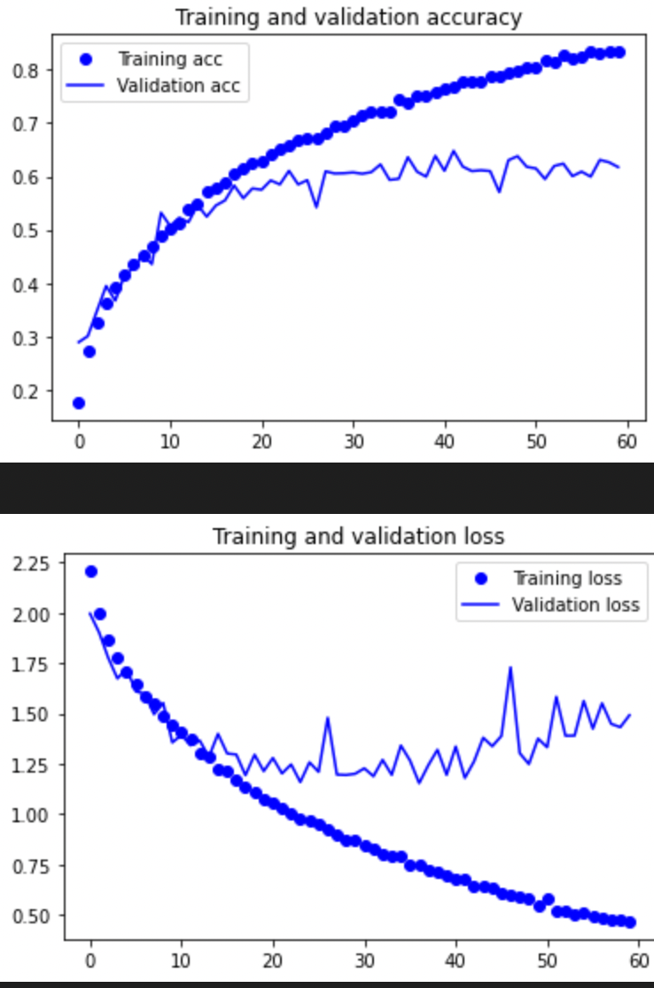

**Conv 128 DEN – 3L 128N**

Val accuracy before overfitting ~ 60%

Overfits ~ Epoch 40

**Analysis**

The models I will be choosing are [Conv 128 DEN - 2L 64N] (original) and [Conv 128 DEN – 3L 64N]. The graphs suggest that the Conv 128 still gives better accuracies than Conv 64. Also, 64 neurons give better accuracies than 128 neurons in the Dense layers. I will refer to the models as SS2 = [Conv 128 DEN – 2L 64N] and SS3 = [Conv 128 DEN – 3L 64N].

We see that the classifier does not need to be complex seeing that its accuracy does not increase much even when the model becomes more complex.

**Currently Selected Models**

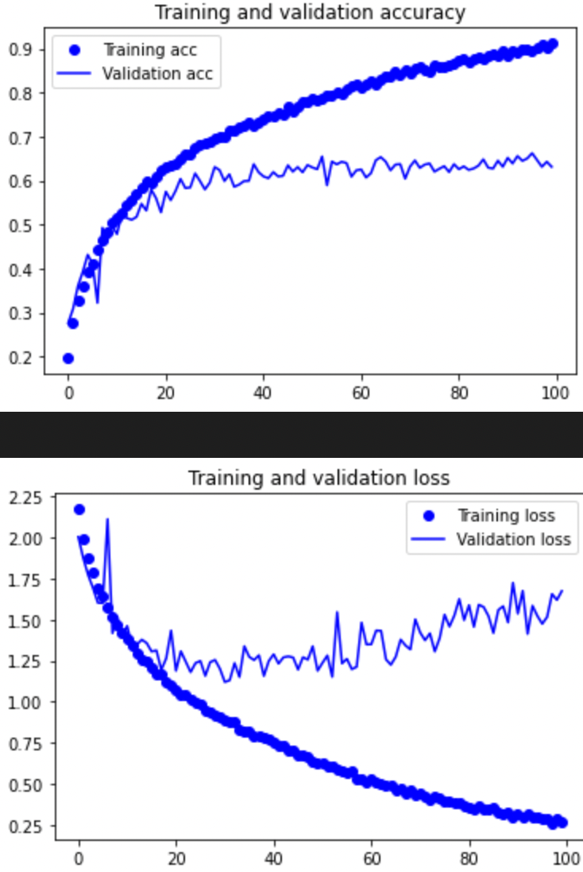

Figure SS2 Figure 2 SS3

1. Optimizers

Optimizers are responsible for tuning the model to minimize the cost function and it is extremely important to pick a suitable optimizer for the model as they make a big difference for training results.

There are two types of optimizers adaptive and gradient descent optimizers. Gradient descent optimizers are very dependent on learning rate and often get stuck in local minimums. Adaptive optimizers do not get affected as much by learning rate and work better on sparse data (variations in the data that are seldom seen by the model).

Aside from Adam which is my current optimizer I will be trying out SGD (gradient descent) and RMSprop (adaptive) to see which is the best.

Regarding the values I used good learning rates for the respective optimizers.

SGD = 0.1, RMSprop = 0.001. Though this might not be the optimal learning rate as every model is different it is a rough estimate. Similarly, the Adam 0.0003 that is used on SS2 and SS3 is just an estimate of a good learning rate.

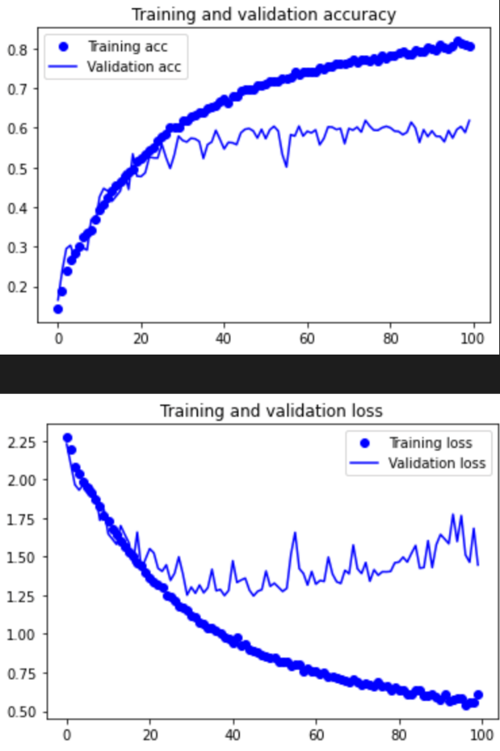

**SS2 SGD 0.1**

Val accuracy before overfitting ~ 57%

Overfits ~ Epoch 50

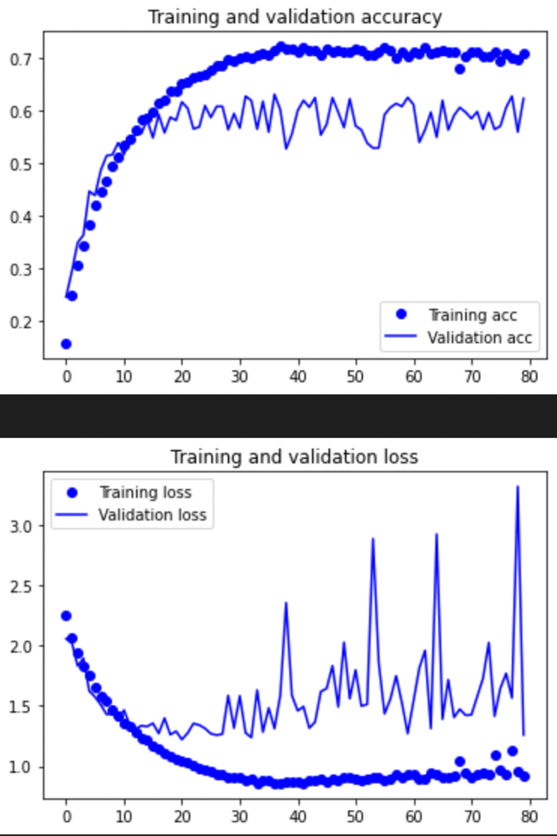

**SS2 RMSprop 0.001**

Val accuracy before overfitting ~ 58%

Overfits ~ Epoch 60

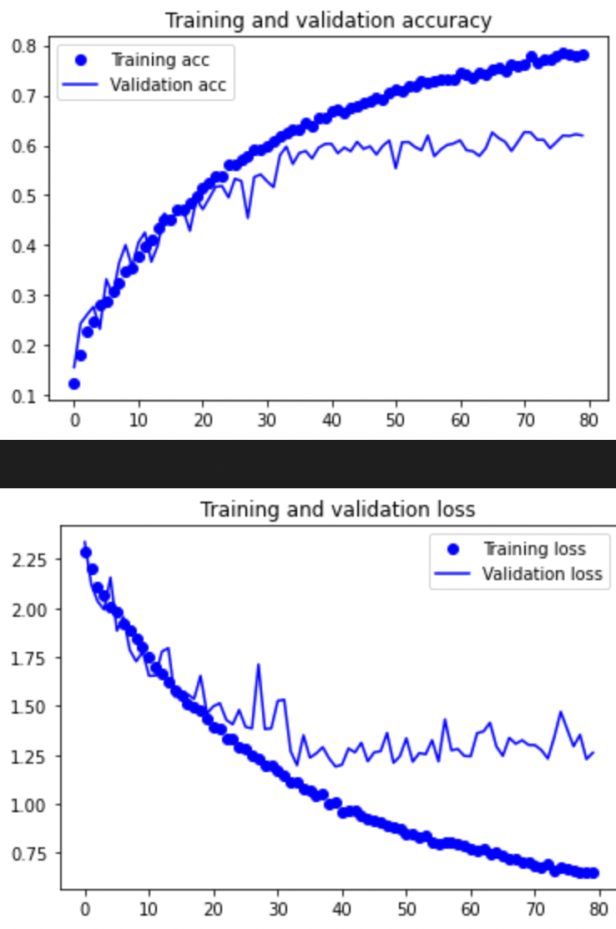

**SS3 SGD 0.1**

Val accuracy before overfitting ~ 58%

Overfits ~ Epoch > 80

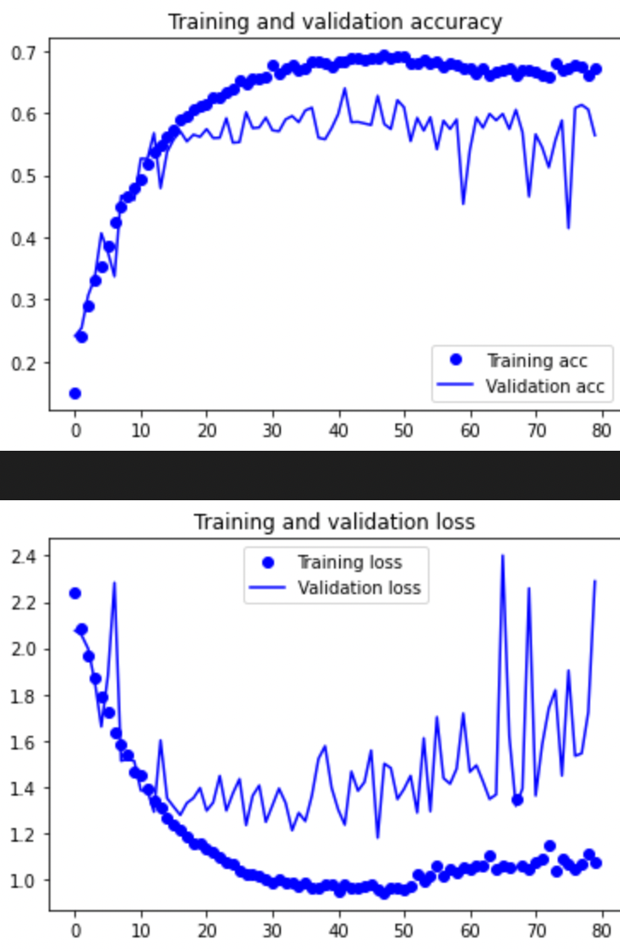

**SS3 RMS prop 0.001**

Val accuracy before overfitting ~ 59%

Overfits ~ Epoch 45

**Analysis**

We see that for both SS2 and SS3, the change in optimizers led to a decrease in accuracy proving Adam to be the best. RMSprop tends to have a lot of noise during training.

Due to time constraints, I will use only SS2 from now onwards.

**Current model selected**

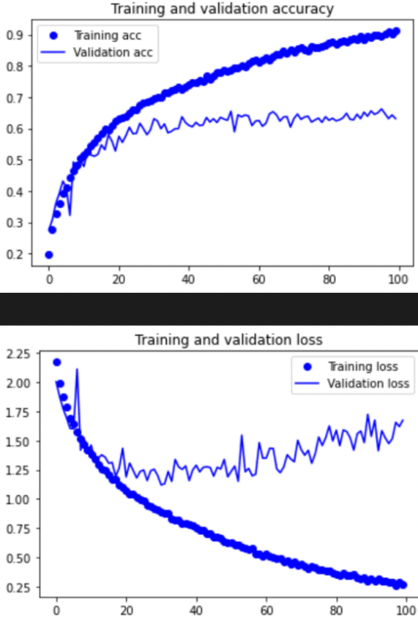

1. Learning Rate

Learning rate comes hand in hand with optimizers and choosing a good learning rate is important to the training of a model.

Learning rate determines the speed at which your model learns. Too fast a learning rate and the model will converge too quickly to a suboptimal local minimum, too small a learning rate and your model will take too long to learn and might get stuck in a local minimum.

My approach is picking a random value and then seeing whether to increase or decrease the learning rate based on the results.

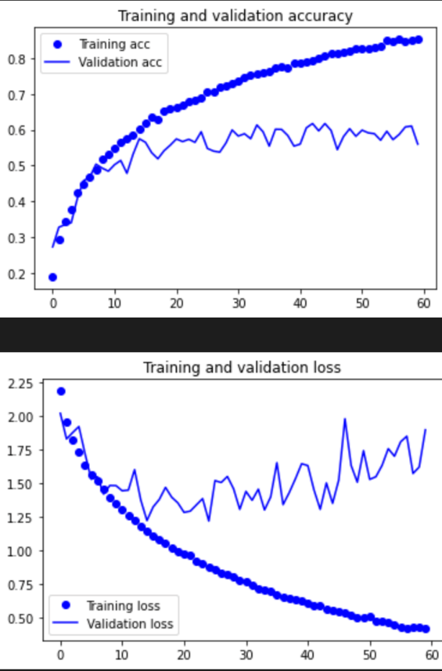

**SS2 lr = 0.0006**

Val accuracy before overfitting ~ 55%

Overfits ~ Epoch 25

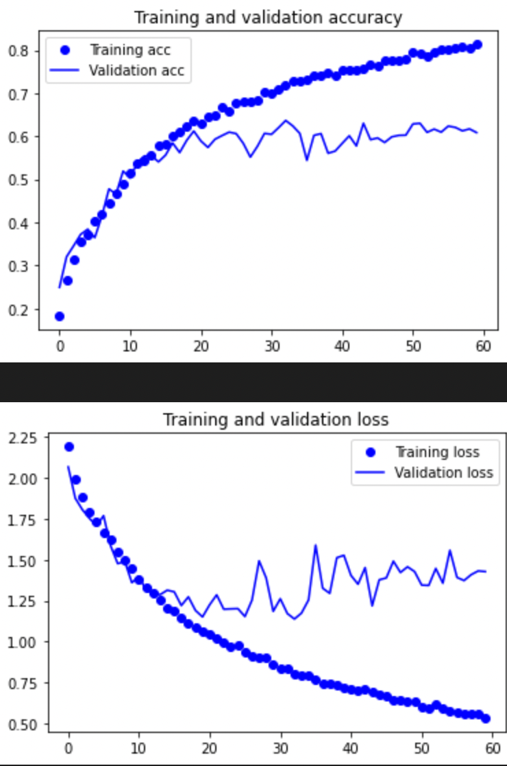

**SS2 lr = 0.0008**

Val accuracy before overfitting ~ 57%

Overfits ~ Epoch 30

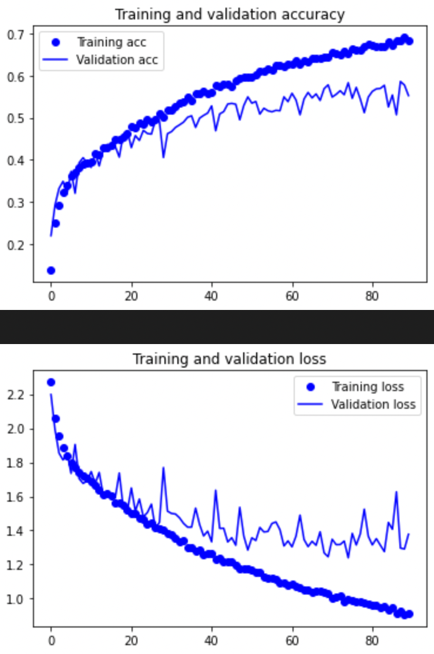

**SS2 lr = 0.00008**

Val accuracy before overfitting ~ 55%

Overfits ~ Epoch 70

**Analysis**

I started out with testing learning rate of 0.0008, however it overfitted very quickly and I lowered it to 0.0006 but it still overfitted early and the accuracies were lower than the original model. So, I tried a learning rate which was smaller than the original of 0.00008 but it also couldn’t hit the same accuracies although it overfitted at a later epoch. Thus, I will still be sticking with lr = 0.0003.

1. Weight Initialization

The purpose of weight initialization is to ensure that the output for the activation function in the layers do not explode or vanish during the training. And if either occurs, then the model will take longer to converge or might not even converge in the end.

I decided to try to tune this hyperparameter as I have never done so before. I tried the Glorot Normal, He Normal, and the LeCun Normal.

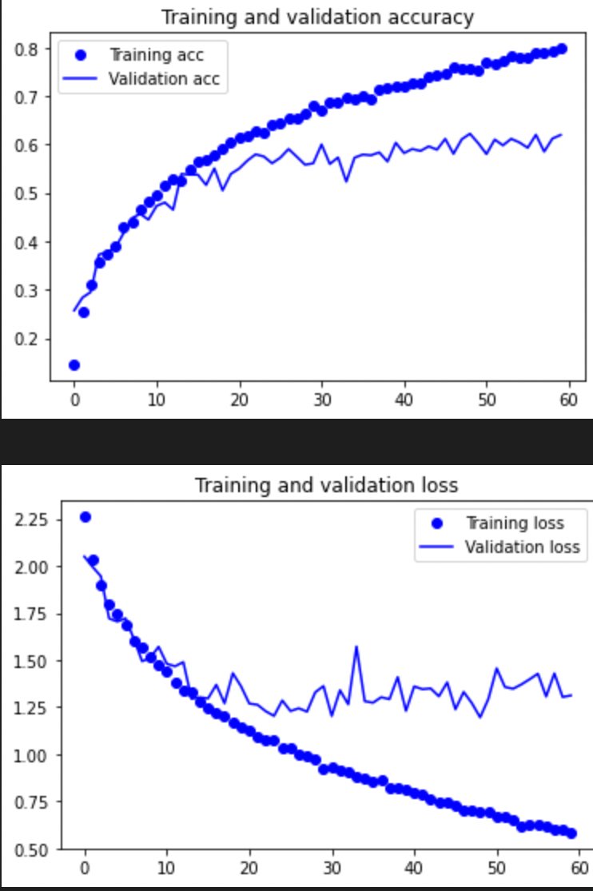

**SS2 Glorot Normal**

Val accuracy before overfitting ~ 57%

Overfits at ~ Epoch 45

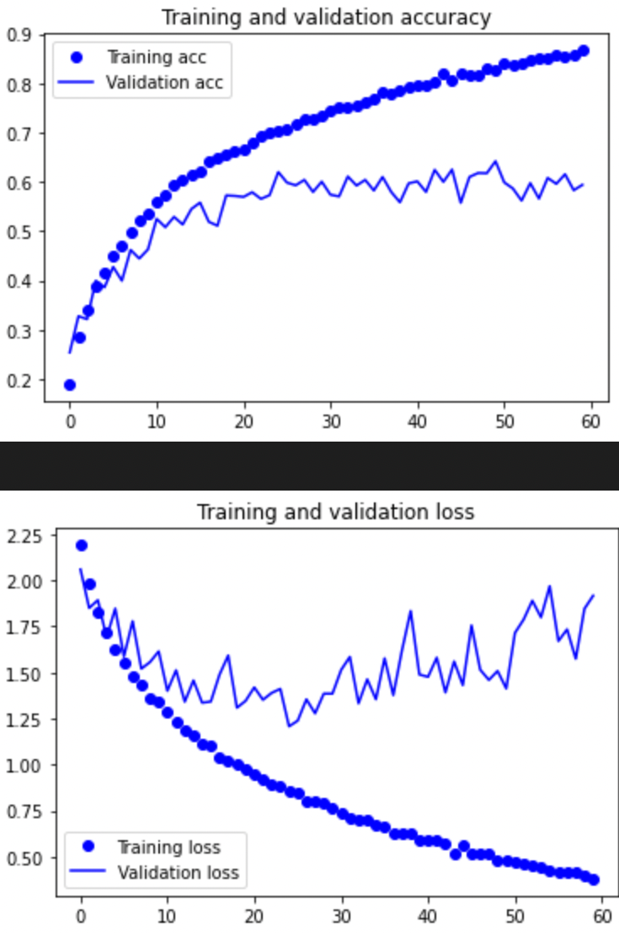

**SS2 He Normal**

Val accuracy before overfitting ~ 58%

Overfits at ~ Epoch 30

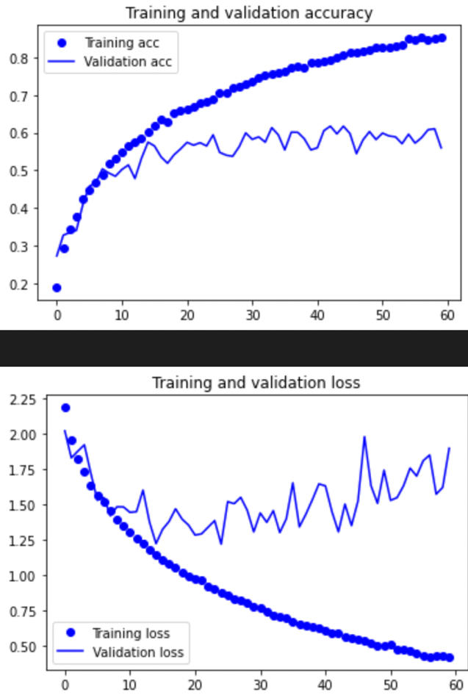

**SS2 LeCun Normal**

Val accuracy before overfitting ~ 57%

Overfits at ~ Epoch 25

**Analysis**

All 3 models with the weight initializers are worse than SS2 (current) and I will not be using any of them.

1. Batch Normalization

Batch normalization are layers added that will perform standardizing and normalizing operations on the input of a layer. The reason this might be useful is that we need to normalize our input so that it is on a common scale allowing our model to generalize appropriately. This also speeds up the training process.

Here I added batch normalization layers between every convolutional layer and maxpooling layer.

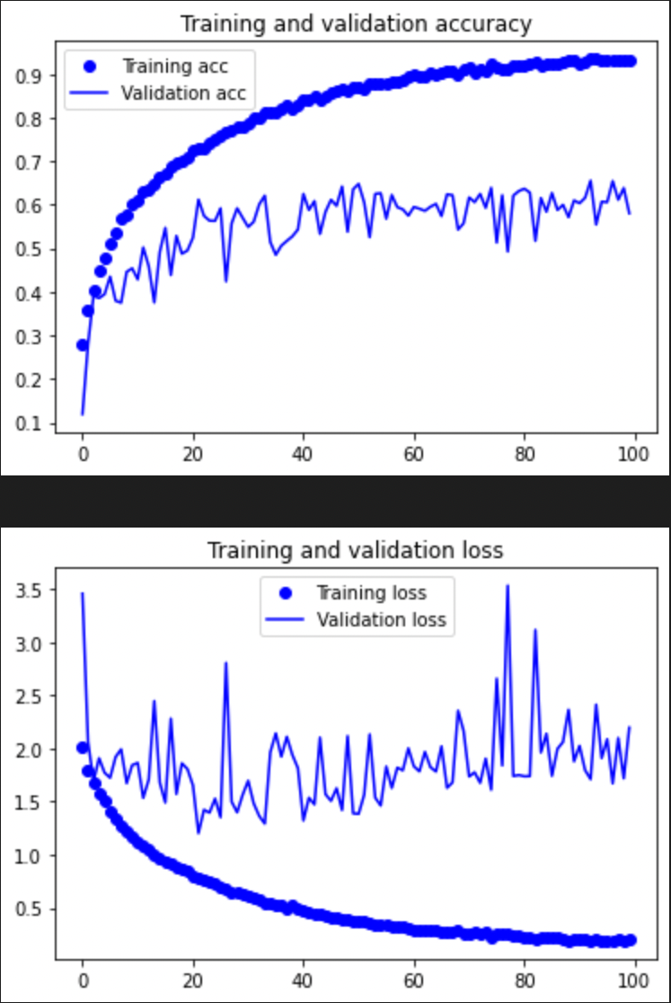

**SS2 Batch Normalization**

Val accuracy before overfitting ~ 57%

Overfits ~ Epoch 30

**Analysis**

Here we can see that there is a lot more noise when using batch normalization and overfitting occurs sooner. The accuracy is also slightly worse. Hence, I will go on with my current model.

1. Dropout

Dropout layers are layers that randomly selects neurons to not participate in the learning while leaving other neurons the way they are. The main purpose of this is so prevent overfitting. This is because the first few batches of training sample influence the learning much more than the data in the later batches. This might prevent the learning of features that only appear in later batches. By “turning off” some neurons, it allows for all neurons to be updated in a non-biased manner.

In this case, I added dropout layers for all my dense layers except for the output layer. Too much dropout and the model will learn too slowly and might get stuck in a local minimum. Too little dropout and its benefits of delaying overfitting will not be felt.

I tested with values of 0.3, 0.5 and 0.7

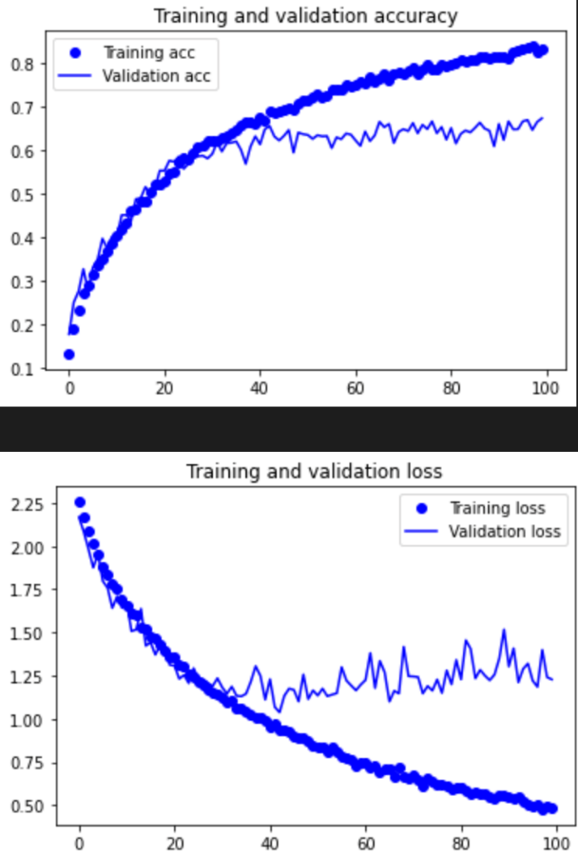

**SS2 Dropout = 0.3**

Val accuracy before overfitting ~ 63%

Overfits ~ Epoch 50

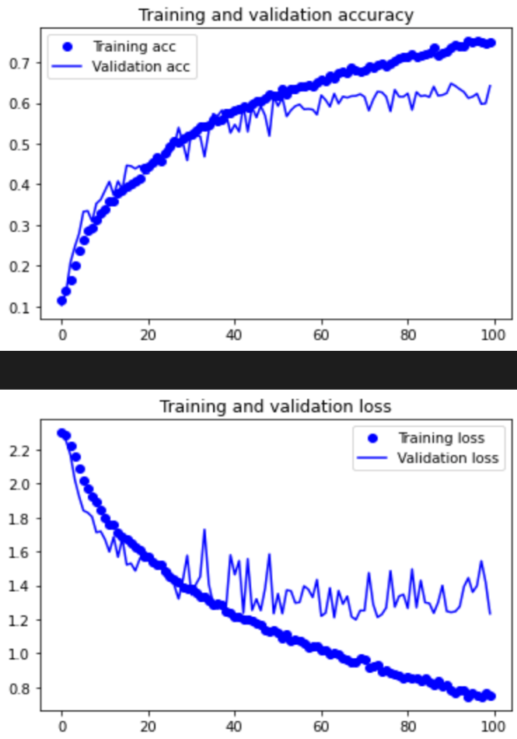

**SS2 Dropout = 0.5**

Val accuracy before overfitting ~ 62%

Overfits ~ Epoch 70

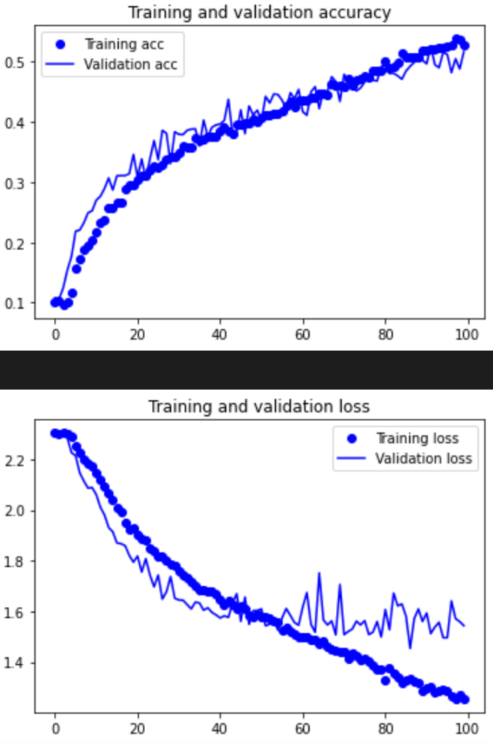

**SS2 Dropout = 0.7**

Val accuracy before overfitting ~ Takes too long to train

Overfits ~ Epoch > 100

**Analysis**

For SS2 no batch normalization, a dropout rate of 0.3 proves to be most effective again giving a validation accuracy of around 63%. 0.7 proves to be too much as the model does not converge after 100 epochs. 0.5 proves to be slightly less optimal then 0.3. Hence, I will also be using 0.3 as my selected model.

**Selected model**



1. Regularizers

Regularizers lower the complexity of the neural network during training to prevent and delay overfitting. It does so by penalizing the neuron values using a value called alpha. The higher alpha is, the worse the penalty. Too high and underfitting will occur as the model will become too simple. Too low and the effects of the regularization will not be felt.

While there are 3 types of regularizers, L1, L2 and L2L1, I will only be tuning L2 as the other 2 has very poor results (forgot to document) and L2 is known to be the best.

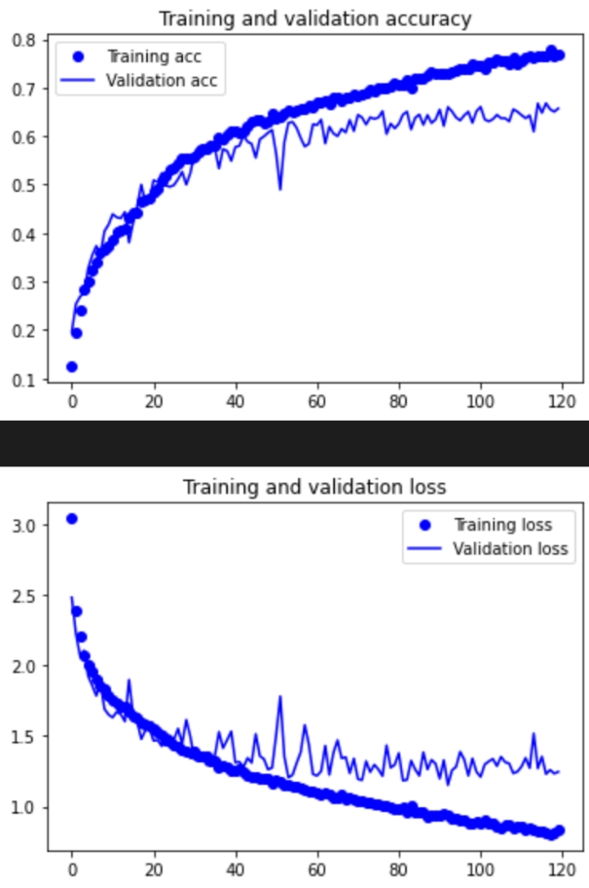

**SS2 L2 = 0.01**

Val accuracy before overfitting ~ 66%

Overfits at ~ Epoch > 120

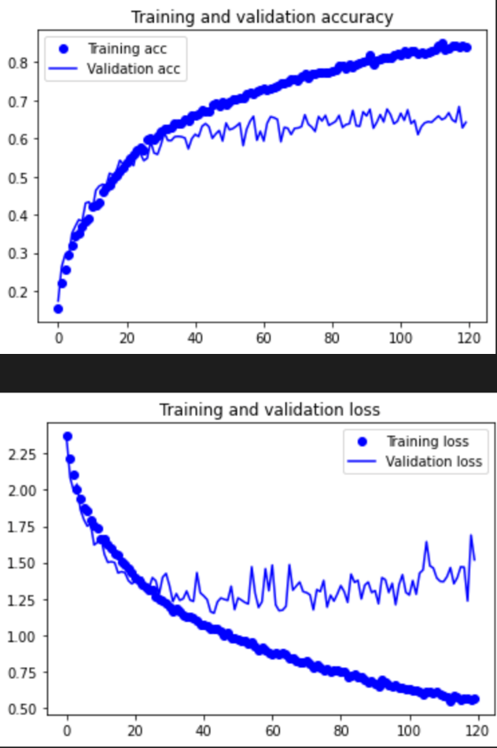

**SS2 L2 = 0.001**

Val accuracy before overfitting ~ 63%

Overfits at ~ Epoch 80

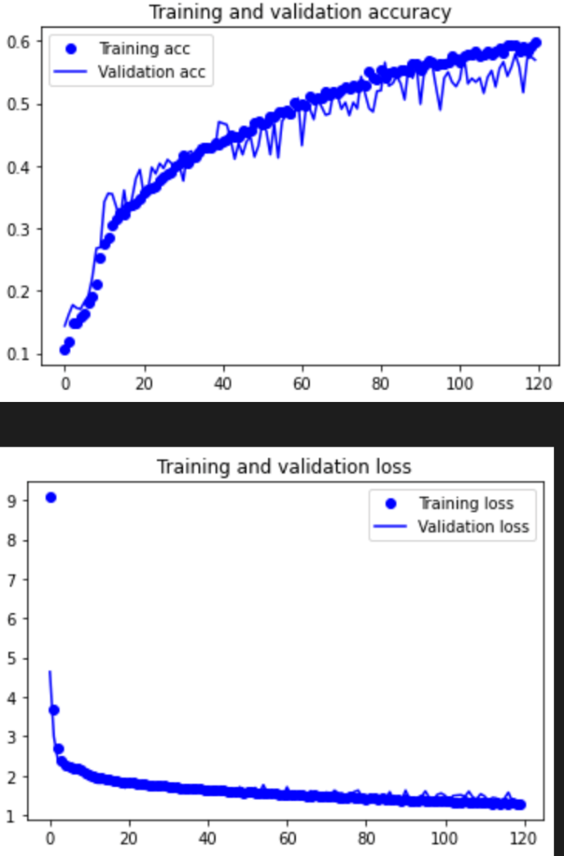

**SS2 L2 = 0.1**

Val accuracy before overfitting ~ 55% (too long to converge)

Overfits at ~ Epoch > 120

# Analysis

I started out with 0.01 and it gave good results with a validation accuracy of 65%, it was however very slow to converge. Hence, I used a lower value of 0.001 next and though it converged faster, the accuracy was lower. Lastly, I tried with 0.1 and the model took too long to converge.

**Chosen Model**

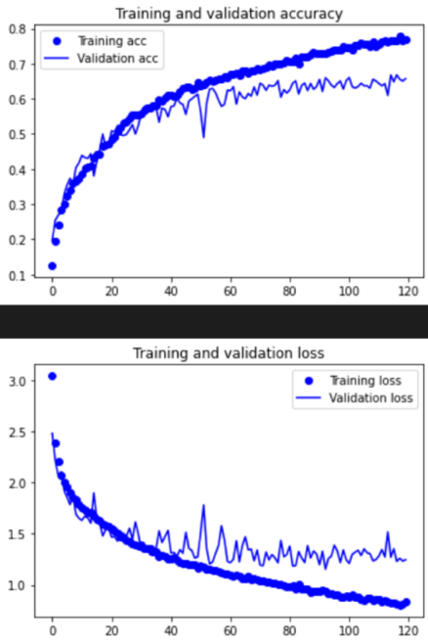

**Pre-Train**

For my pre-train I used the VGG16 model and weights trained for imagenet. As pre-trained models are already trained with a set of weights, the convergence tends to be faster. Hence, I will train the model fewer number of epochs.

**Base model** 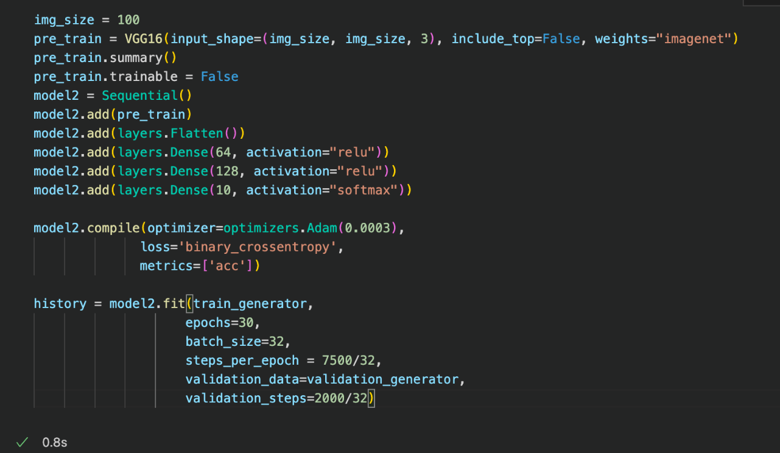

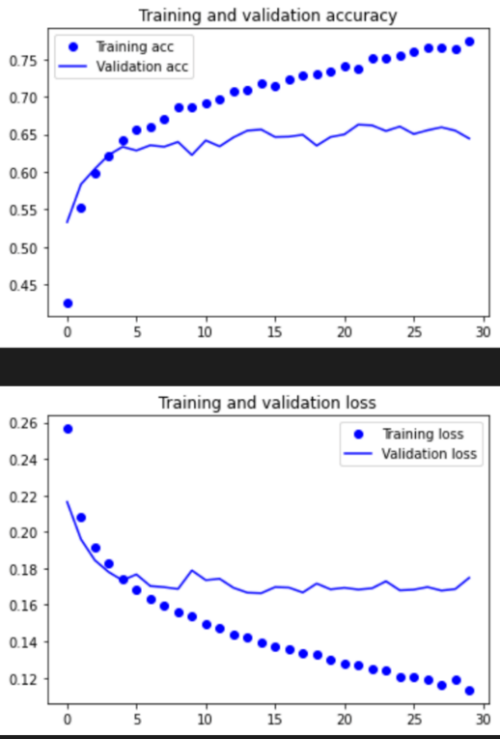

**Pre-Train Base**

Val accuracy before overfitting ~ 64%

Overfits at ~ Loss stagnates at epoch 15

**Fine Tuning**

Fine tuning is the process of unfreezing convolutional layers before the classification model so that their weights will be tuned for the given dataset. This is because layers at the top generally deal with complex features, which would help our model generalize better. For all models the topmost layer, B5C1, was unfrozen.

I also used different classifier architectures to see which one fits best. I experimented with 2 and 3 dense layers excluding output layer. All dropout values are 0.5 and regularizers are L2 (0.01).

**2 Dense Layers**

Val accuracy before overfitting ~ 73%

Overfits at ~ Loss stagnates at epoch 1

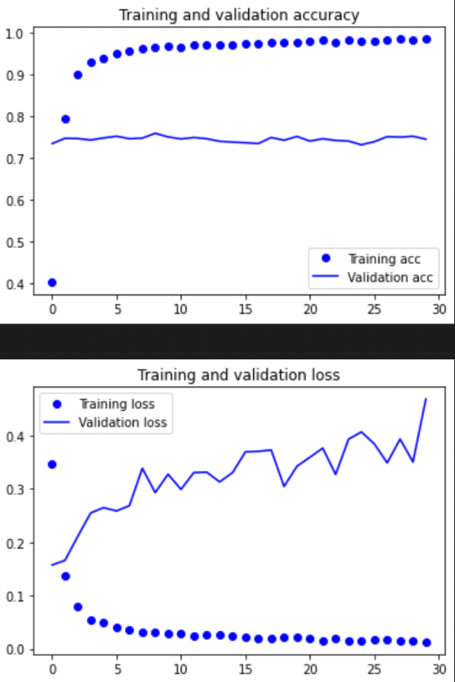

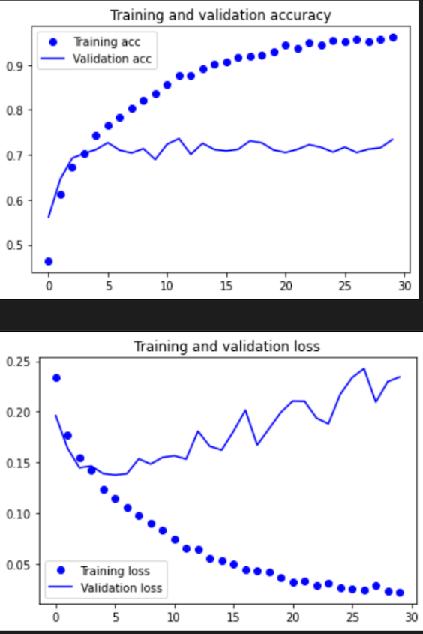

**2 DL + Dropout**

Val accuracy before overfitting ~ 71%

Overfits at ~ Loss stagnates at epoch 7

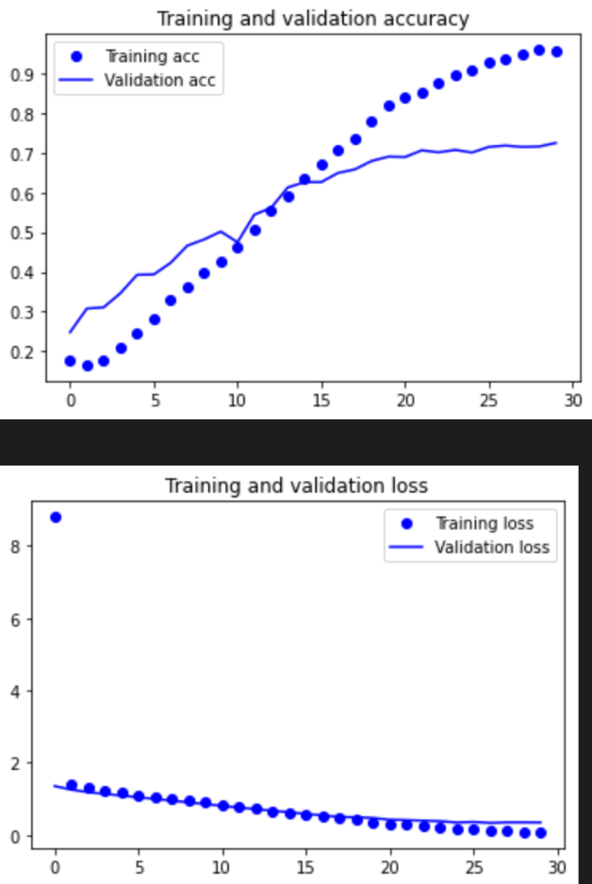

**2DL + DO + Regularizers**

Val accuracy ~ 70%

Overfits at ~ > Epoch 30

Using the overfitting techniques, we were able to delay overfitting however, the accuracies did not improve. For the last model as, I did not fully train it I do not really know its best accuracy. However, from what we can roughly see, the accuracies do not improve. The accuracy is however higher than the base model with not fine tuning

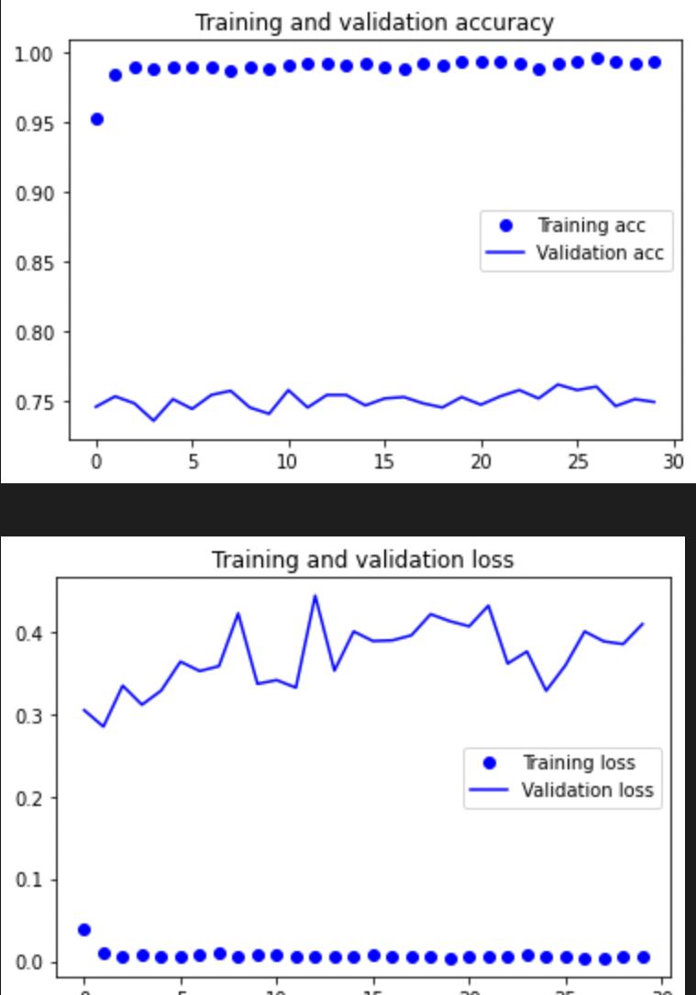

**3 Dense Layers**

Val accuracy before overfitting ~ 75%

Overfits ~ Epoch 25

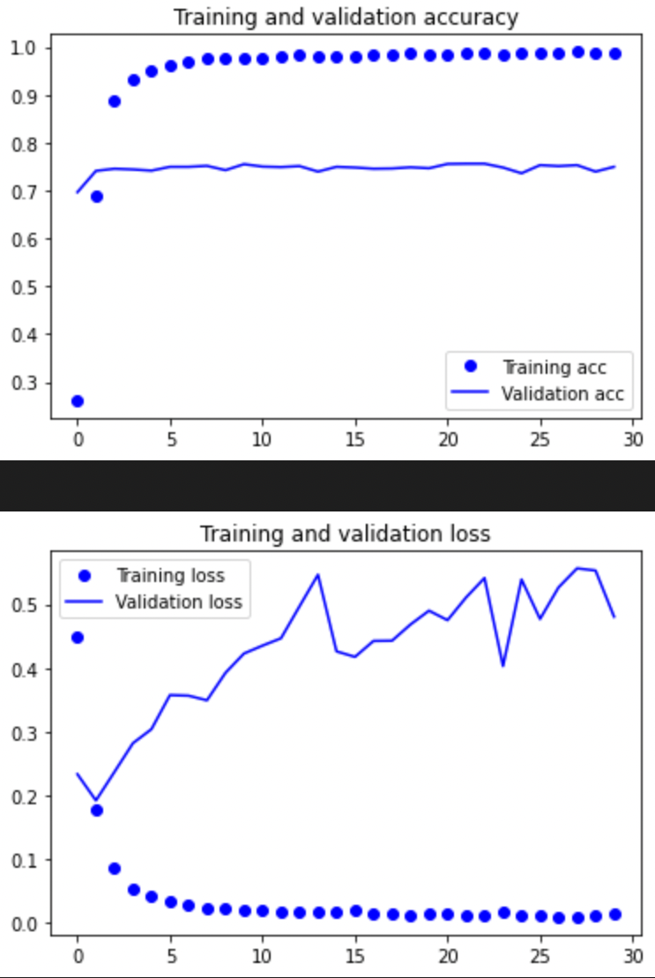

**3 DL + Dropout**

Val accuracy before overfitting ~ 75%

Overfits ~ Epoch 2

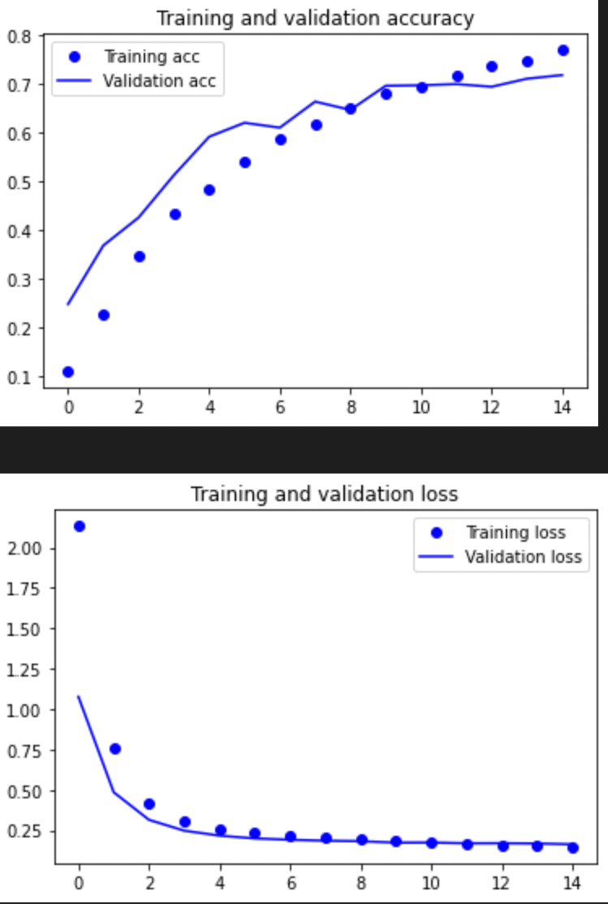

**3 DL + DO + Regularizers**

Val accuracy before overfitting ~ 71%

Overfits at ~ > Epoch 15

Acc rate of increase slows down around epoch 10. But it will still increase.

Here I added an extra dense layer to increase the complexity of the model. Here we see validation accuracy increases to about 75%. Accuracies remained when dropout was added. And based on the general curve of the model with regularizer, it seems unlikely to exceed 75% though I am basing this of my intuition.

Overall, we see that dropouts do not really delay overfitting, but regularization does so very well. This can be seen in both the 2 and 3 layers fine tuning process.

**Selected Model**

From these models I have selected 3DL to be the best performing pre-trained model with a validation accuracy of 75%.



# Evaluate Models Using Test Images

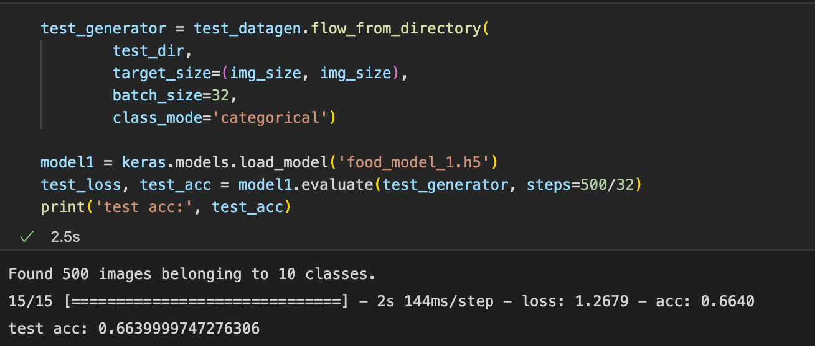

Here we see that model 1 has a test accuracy of 66.4% on the test dataset. It also takes a short time of 2s to train.

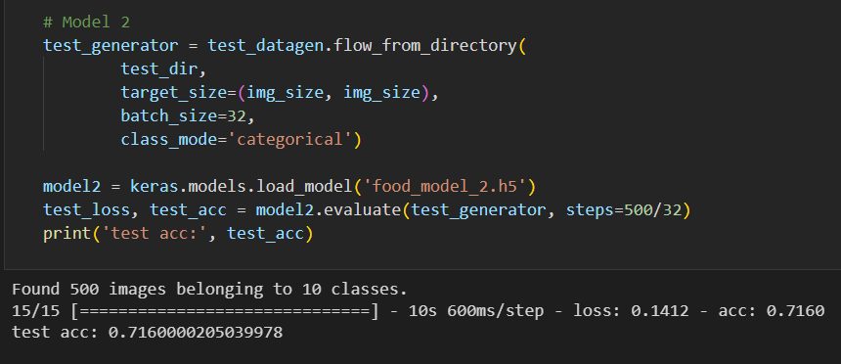

Model 2 has a higher test accuracy of 71.6% thought it takes longer to train. 10 seconds compare to 2 seconds.

Overall, I would say that the best model is model 2 the pre-trained model. This is because it hit higher accuracies of 71.6%. However, if 5% is a small difference and training time is important, then there is a world where model 1 might be preferred.

I would say pre-trained model was able to hit higher accuracies as it has much more parameters compared to model 1, meaning that it is more complex. This allows the model to better learn from the training dataset, giving it better results.

# Use the Best Model to Perform Classification

**Apply model to real life images**

Number one load the possible categories into a list in this case it was food list with the 10 food categories.

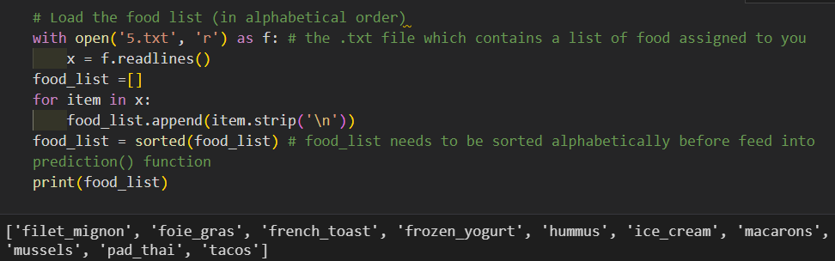

Create some functions that rescales the images and reshapes the variables into an appropriate format.

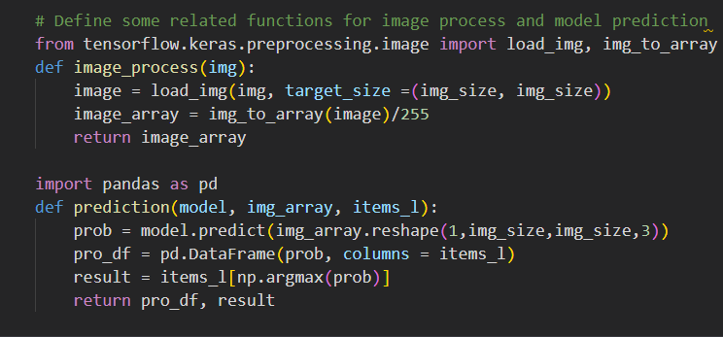

Use the real-life images to make predictions using the prediction method. Compile the results into probabilities for each of the categories that the model has come up with.

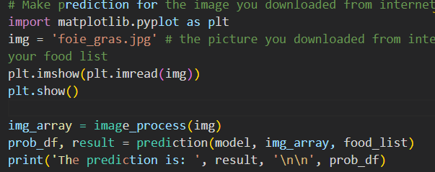

**Model predictions**

I downloaded 5 images of food in my food list from the internet. I then let the model predict what they were. In the end, I had an 80% accuracy rate meaning 4 out of the 5 predictions were correct.

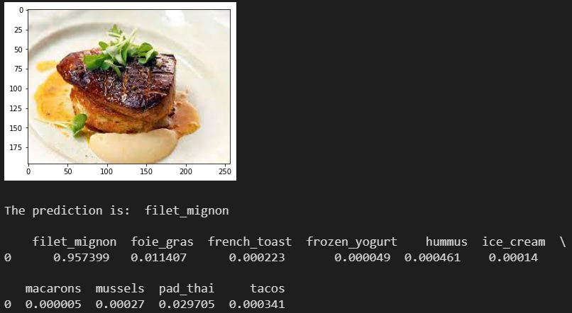

Here the model was 95% confident that the image was a filet mignon however, it was wrong as it was a foie gras. As the colour height and plating of the foie gras is very similar to filet mignon the model might have been confused by it. Also, the top of the foie gras is charred like a filet mignon further making it seem like a filet mignon.

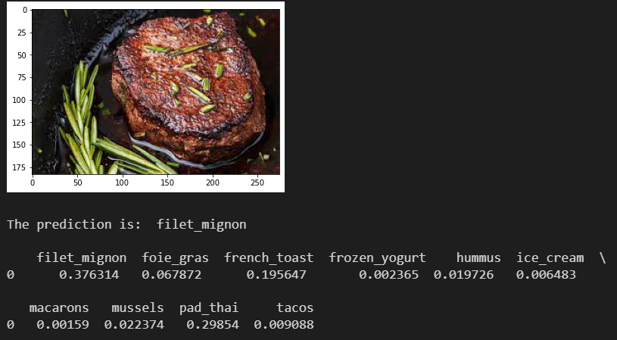

The model here was not confident of its answer as it had a 3-way consideration of filet mignon, French toast, and pad-thai. However, it had the highest probability on filet mignon of 38% making it correct.

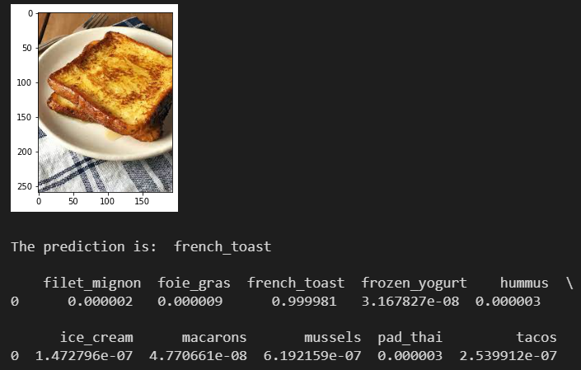

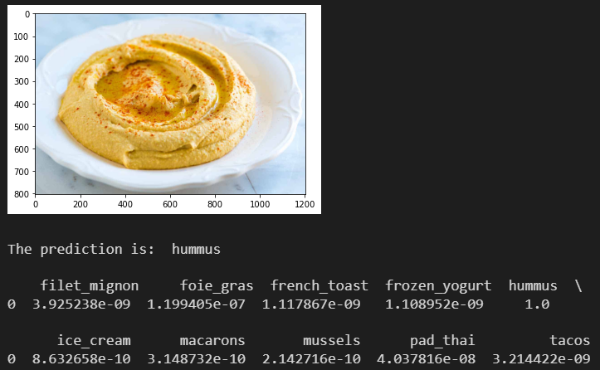

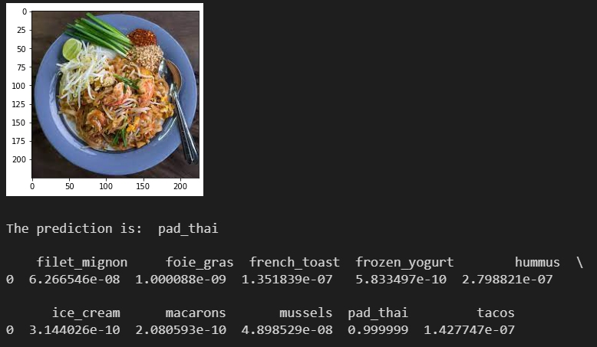

For these images, the model is certain in its prediction and for all 3 it is correct.

# Summary

**Build from scratch**

Overall, the model performance improved significantly from 52% to 66% validation accuracy. While this is a good improvement, there were some flaws in the process of doing it.

Firstly, a model with a not so good accuracy might do very well combined with another hyperparameter and because we only take the models with best accuracies, we miss such hyperparameter combinations. Secondly, some of the models were very close in accuracies and I might have interpreted the graphs with inaccuracies. Also, when there are similar accuracies, sometimes I only chose 1 instead of trying out both. Lastly for some of the models, I could not train till the model overfitted and only took a guess of the estimate of the final validation accuracy before overfitting.

To overcome these problems the key thing is to do more testing on different models or existing models. They are all problems related to time constraints. However, this can also be fixed with a larger dataset as with it, accuracy will improve.

**Pre-train**

The accuracy for my pretrain model went up from 64% to 72% after fine tuning.

I did not run all models to overfitting and used their stagnated accuracy as an estimate. I also did not tune certain hyperparameters value such as dropout. Instead, I used 1 value for all my dropout. Lastly, there can be inconsistencies with me reading the graphs.

Similarly, running more models as well as having more data would be great fixes for these problems. The inconsistency with interpreting the graph’s values can be fixed with me cross checking with someone.